Project 2: Transformations  
CS 6610-001 Spring 2019

For this assignment, using C++, I implemented a program that displays the vertices of a teapot object. he window was sized explicitly with 1:1 aspect ratio and allows the user to recompile the shaders at runtime by hitting the F6 key and exits when the ‘Esc’ key is pressed. Left mouse click and drag reorients the pot and right click and drag adjusts the distance from the pot.

The project requires the following headers to be included and was compiled in Visual Studio on Windows:

#include <GL/glew.h>

#include <GL/freeglut.h>

#include <iostream>

#include <cyCore.h>

#include <cyPoint.h>

#include <cyMatrix.h>

#include <cyTriMesh.h>

#include <cyGL.h>

See below for screenshots demonstrating the rotation, zoom and recompiled versions: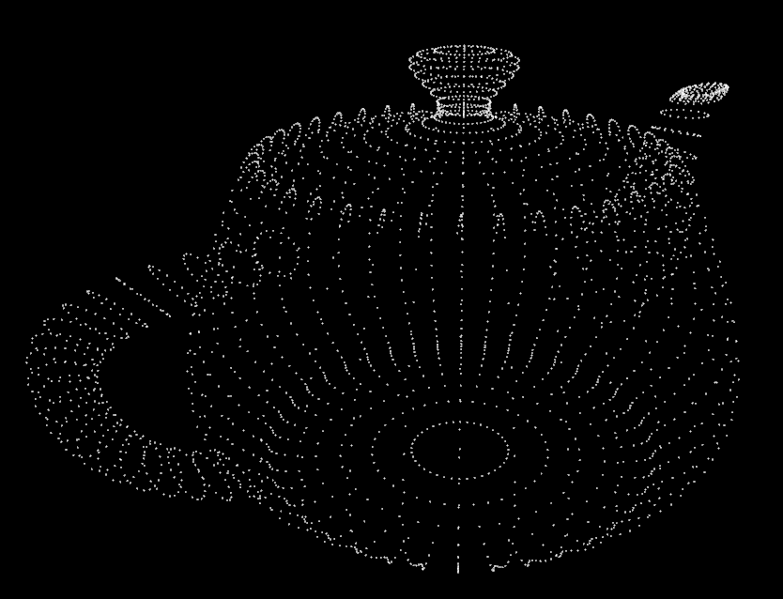

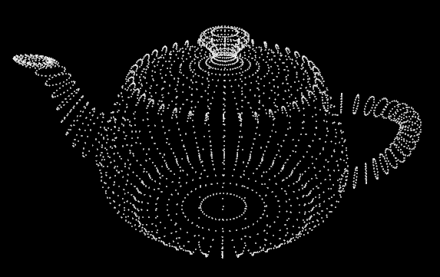

Recompiled during runtime by hitting F6: